The Craigslist design so far is acceptable. The raw basic, text design makes it easy to navigate and fast to load on a browser, especially for places where wifi signal is bad. However, there are a lot of links that I would assume no one really goes to. Some of are even redundant. For example, on the homepage, the terms of service: the privacy, policy, etc… are repeated twice. One list is on the sidebar, and one is on the footer of the page. The search criterias can also be collapsed. For example, where the left sidebar says “nearby cl”, users will usually not search nearby places. They will look for products and services, and see how far away it is.

On the results page, it is a little better. It’s less cluttered. However, if you go to a Google or even Bing results page, there are collapsible search criteria. You don’t need every possible search criteria shown. You can simply select and choose. Also, at the top of the page,



This is unnecessary since there is a search bar right below it. If they coded the search engine well, the user can simply enter key words and search there, or the search engine can offer suggestions as they type, like Google.

On the item page, there is too much empty space to the right of the page.

These safety tips and other warnings should be gone, since the user does not have to be reminded on every page other than the homepage. The condition could stay.

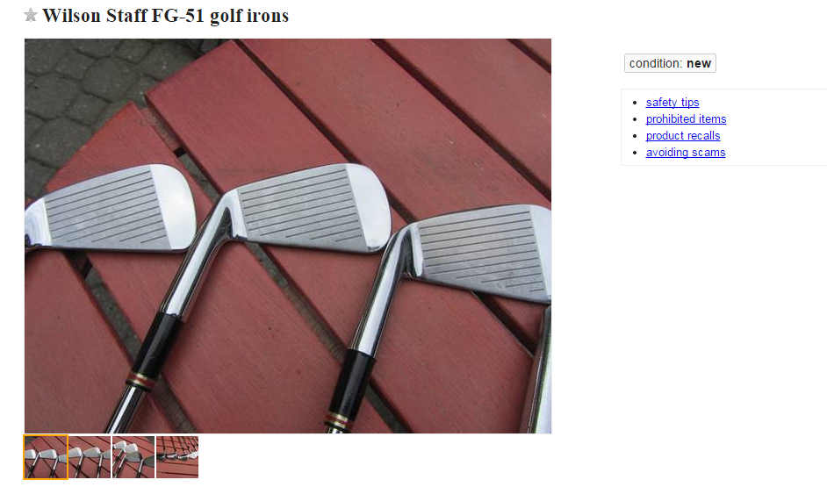

This space can be used to put another picture, so that the user can compare multiple pictures side by side. If someone was looking at an item, they would want to compare the different pictures. Furthermore, the description should not be so far down the page that the user has to scroll down to read it. Also, the search engine should be on this page as well, since I don’t want to have to go back and reload the page just to search for another item.

\*For mobile and tablet designs, the designs should roughly be similar. However, there would be much more collapsible tabs.